ASSIGNMENT-10.1
N. Soukya
2303A51401
Batch-24

Task Description #1 – Syntax and Logic Errors
Task: Use AI to identify and fix syntax and logic errors in a faulty
Python script.
Sample Input Code:
# Calculate average score of a student
def calc_average(marks):
total = 0
for m in marks:
total += m
average = total / len(marks)
return avrage # Typo here
marks = [85, 90, 78, 92]
print("Average Score is ", calc_average(marks)
Expected Output:
• Corrected and runnable Python code with explanations of the
fixes.
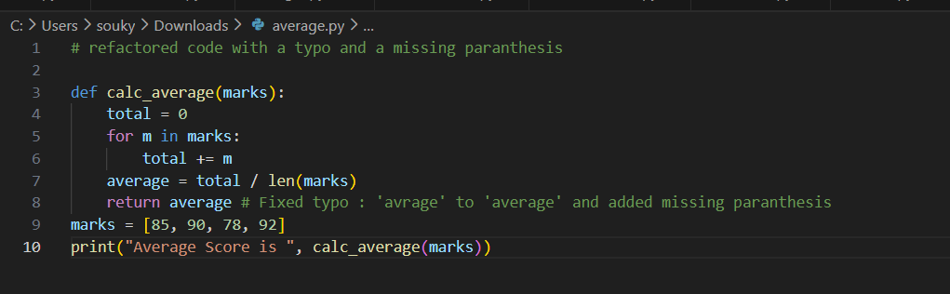
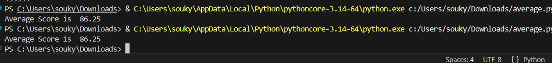
Task Description #2 – PEP 8 Compliance
Task: Use AI to refactor Python code to follow PEP 8 style
guidelines.
Sample Input Code:
def area_of_rect(L,B) : return L*B
print(area_of_rect(10,20))
Expected Output:
• Well-formatted PEP 8-compliant Python code.
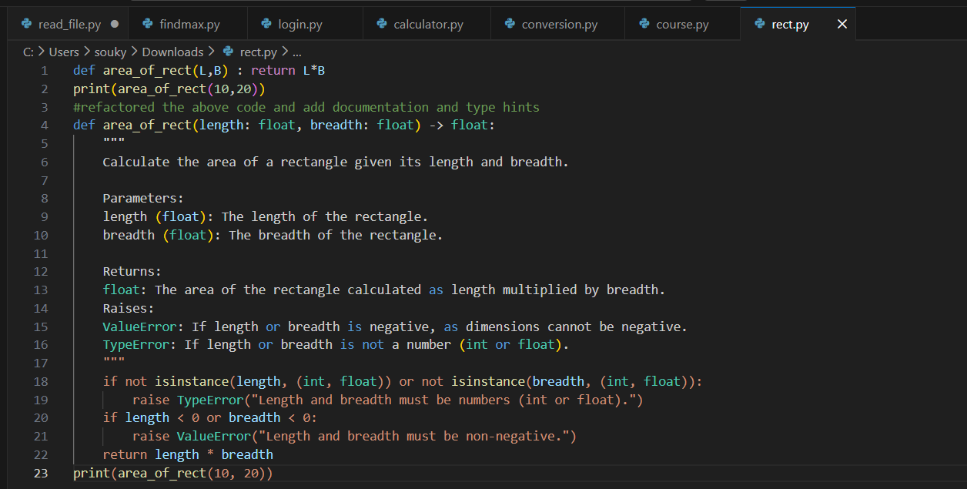
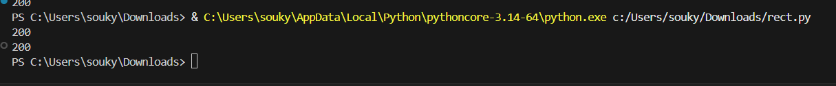
Task Description #3 – Readability Enhancement
Task: Use AI to make code more readable without changing its
logic.
Sample Input Code:
def c(x,y):
return x*y/100
a=200
b=15
print(c(a,b))
Expected Output:
• Python code with descriptive variable names, inline
comments, and clear formatting.
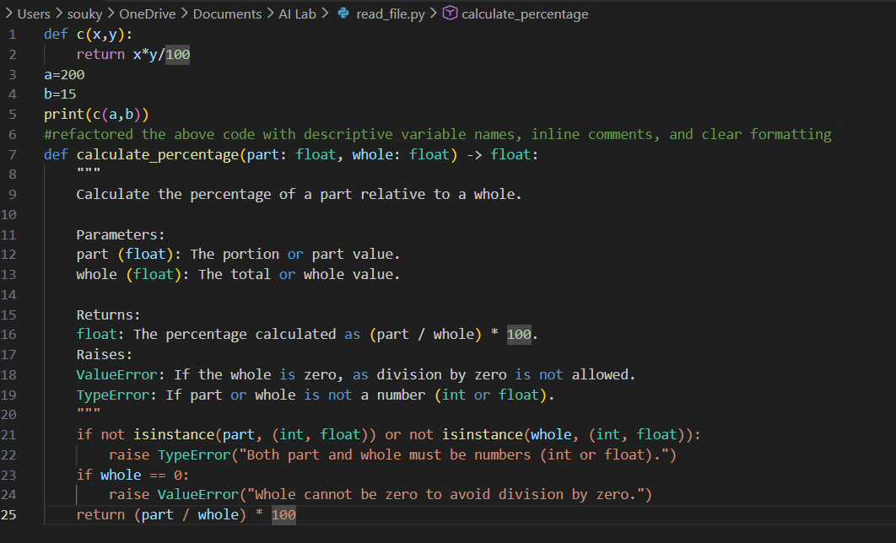
Task Description #4 – Refactoring for Maintainability
Task: Use AI to break repetitive or long code into reusable
functions.
Sample Input Code:
students = ["Alice", "Bob", "Charlie"]
print("Welcome", students[0])
print("Welcome", students[1])
print("Welcome", students[2])
Expected Output:
• Modular code with reusable functions.
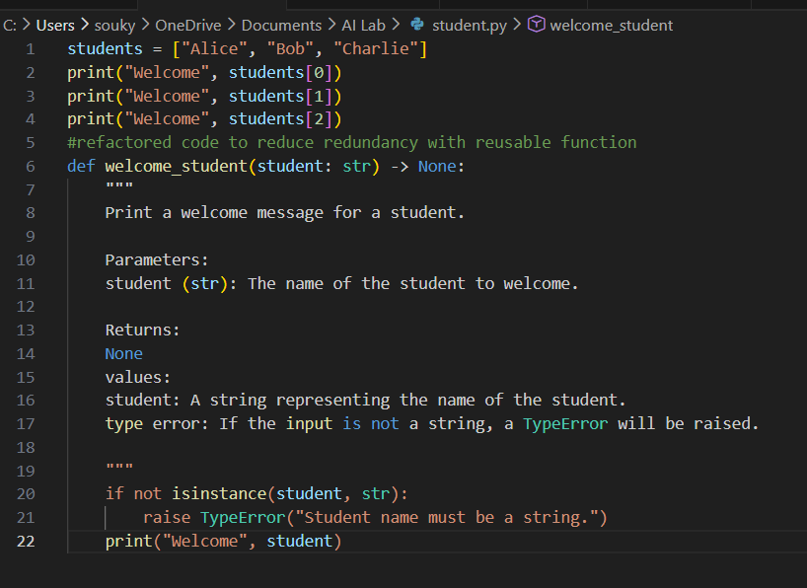
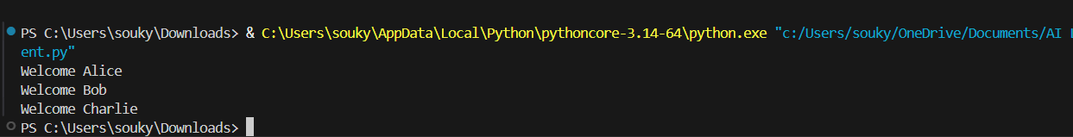
Task Description #5 – Performance Optimization
Task: Use AI to make the code run faster.
Sample Input Code:
# Find squares of numbers
nums = [i for i in range(1,1000000)]
squares = []
for n in nums:
squares.append(n**2)
print(len(squares))
Expected Output:
• Optimized code using list comprehensions or vectorized
operations.
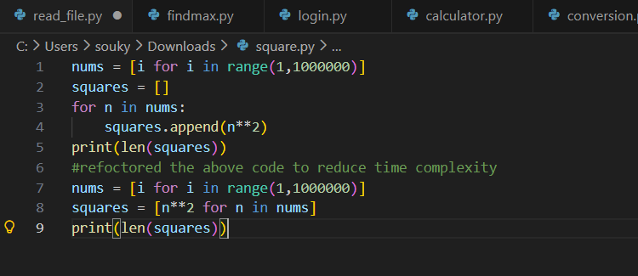
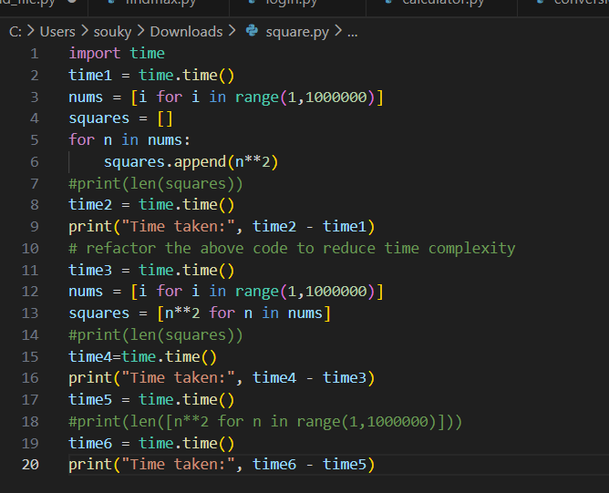
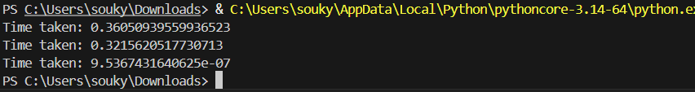
Task Description #6 – Complexity Reduction
Task: Use AI to simplify overly complex logic.
Sample Input Code:
def grade(score):
if score >= 90:
return "A"
else:
if score >= 80:
return "B"
else:
if score >= 70:
return "C"
else:
if score >= 60:
return "D"
else:
return "F"
Expected Output:
• Cleaner logic using elif or dictionary mapping.
